RESOLUTION NO.__________

RE: CERTIFICATE OF APPROPRIATENESS UNDER THE
PROVISIONS OF THE ACT OF THE PENNSYLVANIA
LEGISLATURE 1961, JUNE 13, P.L. 282 (53
SECTION 8004) AND BETHLEHEM ORDINANCE NO.
3952 AS AMENDED.

WHEREAS, it is proposed to install window signage at 305 West 4th Street.

NOW, THEREFORE, BE IT RESOLVED by the Council of the City of Bethlehem that a Certificate of Appropriateness is hereby granted for the work.

Sponsored by: (s)

(s)

ADOPTED BY COUNCIL THIS DAY OF

(s)
President of Council

ATTEST:

(s)
City Clerk

HISTORIC CONSERVATION COMMISSION

CASE # 470 – It is proposed to install window signage at 305 West 4th Street.
OWNER/APPLICANT: Bethlehem Drug Store LLC C/o Kline Scott Visco / Kimmie Whitford

The Commission upon motion by Mr. Lader seconded by Mr. Cornish adopted the proposal that City Council issue a Certificate of Appropriateness for the proposed work described herein:
- The proposal to install window signage at 305 West 4th Street was presented by Ms. Ussler at the request of the applicant who is located out of town.
- The new signs will be located on the storefront windows on either side of the entrance. The graphics will consist of black and white historic photos of the Bethlehem Steel Mill.
- The proposed signs will contain no lettering. They will replace vacuum panels at the bottom of both sets of windows.
- On the left set of windows, vinyl window graphics will cover a strip of the glazing where the backs of shelving inside the store are exposed.
- Overall, the proposed graphics for the windows on the left will be 32' long and no more than 3' 6" high.
- The proposed graphics for the windows on the right will be 27' wide and no more than 4' 9" high overall.
- It is strongly recommended to remove or subdue the “balloon” graphic overlay, if possible. The design was approved as submitted, however, with the understanding that the “balloons” were a corporate requirement.
- The proposed motion was unanimously approved.

CU: cu

By: 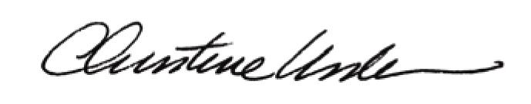

Date of Meeting: October 21, 2013 Title: Historic Officer

